System Architecture
Task & Job Description Management — v1 · decisions & open paths
3 August 2026 · companion to the functional specification v3
How to read this document. Each choice carries one of three labels: DECIDED (we build on it), DEFAULT — easy to swap (we start with it, and the path to swap it is written down), OPEN — to audit (needs an audit or a client answer). The guiding rule everywhere: simple, but with the scaling path documented — every extra service must earn its place.

1 · Context & hard constraints
- Fully air-gapped. The factory LAN has no internet access, ever. No cloud push services (FCM / Web Push), no Let’s Encrypt, no external NTP, no pulling images or packages on site. Everything ships as files.
- Hardware: Raspberry Pi. One dedicated Pi per role. Databases must live on NVMe / SSD — continuous writes destroy SD cards within months.
- Scale is small. ≈400 employees, roughly 3–8k task instances generated per day, 2–3 million rows per year, ≈100–150 concurrent users at the morning peak. A single Pi 5 could run everything; we split for resilience and clean scaling, not for load.
- Nobody works at night. A guaranteed idle window every night for the recurring-task generation job, backups and any heavy maintenance.
- Application stack is already set (functional spec v3): Next.js App Router + Server Actions, Drizzle ORM, Better Auth (credential-based — works fully offline), PostgreSQL.

2 · Topology — three Raspberry Pi
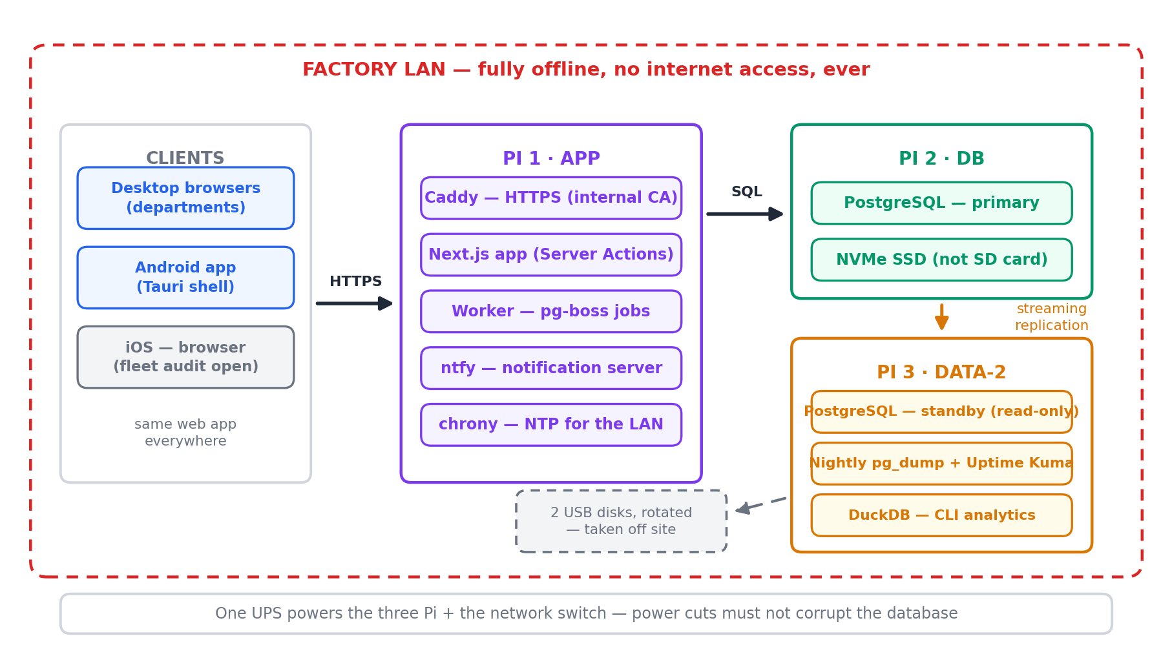
Diagram A1 — the whole system lives inside the factory LAN; disks rotated by hand replace off-site network backup.
Node | Runs | Why it exists
Pi 1 · APP
Pi 2 · DB
Pi 3 · DATA-2
All three run 64-bit Raspberry Pi OS Lite + Docker Compose. Everything is a container except chrony.

3 · Technology decisions

3.1 · PostgreSQL, in Docker DECIDED
The schema, the offboarding transactions, the idempotency of the recurring-task generator (unique index on recurring_id + due_date) and the KPI window functions are already designed for Postgres. At our volume it runs without noticing on a Pi 5 + NVMe; table partitioning is not worth it before ≈50 M rows — revisit around year 15.
- Alternative considered — SQLite: would carry the load, but multi-node (app + worker + standby) and streaming replication make Postgres the boring, safe choice.

3.2 · No cache layer in v1 DEFAULT — easy to swap
Well-indexed Postgres answers our dashboard queries in milliseconds for 400 users; a Redis cache in front mostly buys invalidation bugs (“the manager still sees a task that was already checked”). ClickHouse is an analytics engine for billions of rows — wrong tool here.
- When to add one: if a measured dashboard query stays slow after indexing, add Valkey (open-source Redis) on Pi 3, or simply point heavy read-only queries at the standby. Both are afternoon-sized changes.

3.3 · Jobs: event-driven first — pg-boss, inside Postgres DEFAULT — easy to swap
Everything user-triggered is real time. A Server Action commits and enqueues the follow-up job in the same transaction; the worker picks it up in well under a second; the UI hears about it over SSE. No polling loops, no system crontab. Scheduled work is the exception, reserved for what is scheduled by nature: the nightly generation of recurring instances, the Missed evaluation at cut-off times, and backups — recurrence does not need to be real time, and must not be resource-hungry.
pg-boss carries both patterns — queues, retries, delayed jobs and scheduling, as a Node library storing its state in Postgres: zero extra service, zero extra Pi, jobs survive restarts. Note that the mechanism for Missed evaluation — one global sweep at a fixed cut-off, or one delayed job per instance — depends directly on open point E (see section 12).
- Alternative kept open — BullMQ + Redis: better tooling and dashboards, standard in bigger shops. The job payloads stay identical, so migrating later is mechanical. Trigger: notification volume ×10, or a need for a queue UI.

3.4 · Analytics & fast CLI reads: DuckDB on the standby DECIDED
DuckDB attaches to the standby Postgres (never the primary) for ad-hoc analytics — per-customer analysis via the customer tag, KPI explorations — at interactive speed, with zero impact on production. Optionally, a nightly Parquet export gives free historical snapshots. This is a tool, not an infrastructure component.

4 · Notifications — pluggable by design
Air gap rules out classic Web Push (VAPID goes through Google/Apple servers) and Mattermost’s mobile push (hosted push proxy). What works fully offline:
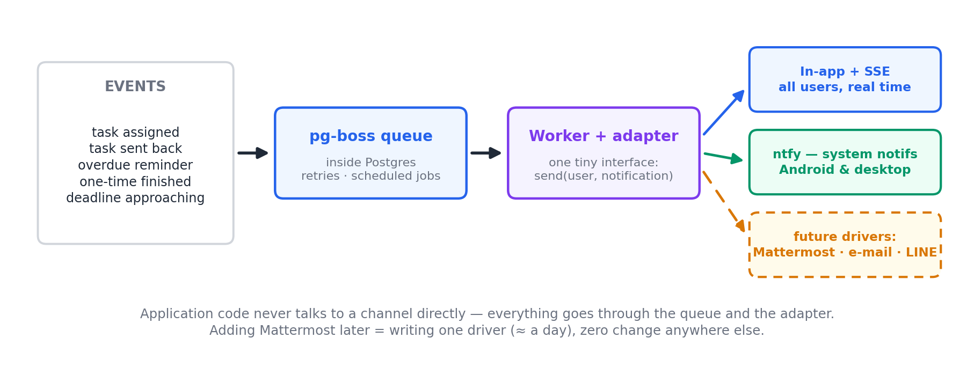
Diagram A2 — one queue, one adapter interface, drivers behind it. Channels are configuration, not architecture.
- In-app + SSE — the notification list in the app, updated in real time over Server-Sent Events while the app is open (which is: during working hours). DECIDED
- ntfy — a tiny self-hosted notification server (one small Go container on Pi 1). Its Android app keeps a WebSocket to our LAN server and shows real system notifications — no internet involved. Desktop browsers can subscribe too. DEFAULT — easy to swap
- Mattermost / team chat — OPEN — to audit There is no Mattermost today. If the client only needs to be notified, a chat platform is oversized (extra server, extra database, extra admin). If they decide they also want internal messaging, we deploy Mattermost (or a lighter alternative) as its own project — and plug it into our adapter as one more driver. The audit question for the client: “do you want notifications, or also a chat tool?”
The seam that keeps it pluggable: application code never calls a channel directly. Every event goes through the pg-boss queue to the worker, which fans out through one small interface:
interface NotificationDriver {
send(userId: string, n: { title: string; body: string; taskId?: string }): Promise<void>;
}
// v1 drivers: InAppDriver (DB row + SSE) · NtfyDriver (HTTP POST to ntfy)
// future: MattermostDriver · EmailDriver · LineDriver — same interface, enabled by config
Adding Mattermost later is one driver (≈ a day of work) and a config switch — nothing else changes.

5 · Integration & API — one module in a larger architecture
This system is the first module of a larger architecture. The anti-regression insurance is where the business logic lives — not a separate API server that would serve no consumer for years. Four cheap decisions make any future extraction mechanical:
- Service layer, transport-agnostic. DECIDED All business logic lives in src/services/ — pure TypeScript, Zod contracts in and out, Drizzle transactions inside. Server Actions become three-line adapters (auth + service call). Hard rule, lint-enforced: no Drizzle import outside services/. Exposing the same logic over REST, CLI or a worker then costs three lines each; extracting a standalone API server one day = moving a folder.
- A minimal, versioned REST facade from v1. DECIDED Not “the full API” — only the plausible integration seams, as Route Handlers in the same Next.js: GET /api/v1/tasks, task instances, departments & positions, KPI summaries, and POST /api/v1/tasks for one-time tasks (the most likely external need). Machine auth via hashed API keys — Better Auth handles humans, not modules. OpenAPI generated from the Zod schemas: the contract exists for future modules and for AI agents — openapi.json joins docs/machine/.
- Domain events (outbox). DECIDED The transactional enqueue already used for notifications generalises into a domain_events table (task.created · task.checked · task.missed · holder.changed…) dispatched by the worker — to notifications today, to other modules’ webhooks tomorrow. For inter-module needs the event stream is often worth more than REST: a future HR module reacting to departures polls nothing.
- The database is private. DECIDED No other module ever writes to our Postgres — database coupling is what actually kills modular architectures. Analytics reads: standby / DuckDB. Writes: API or events, full stop.
- Deliberately not built (triggers documented): a separate API server (trigger: a second heavy frontend, or a module needing independent scaling — extraction is mechanical thanks to the service layer) · GraphQL / gRPC (no consumer justifies them) · an API gateway (we run three Raspberry Pi).
Two integrations already on the horizon will prove these seams in v1, not in theory: the legacy employee-database sync (the stored employee code) and the customer database (the customer tag) — import jobs + references, flowing through exactly these seams.

6 · Data: replication, backups, restore
- Streaming replication (async), continuous — Pi 3 holds a live standby, seconds behind the primary, queryable read-only. Failover = one command (pg_ctl promote) plus pointing the app’s DATABASE_URL at Pi 3. DECIDED
- A replica is not a backup — a bad DELETE replicates in seconds. So: nightly pg_dump on Pi 3 during the idle window, 30 days retained.
- Off-site, without a network — two USB disks rotated by hand: one plugged into Pi 3, one stored outside the factory, swapped on a weekly rhythm.
- Restore is rehearsed — once before go-live and once a quarter, we actually restore a dump onto a spare SD image and boot the app against it. An untested backup is a hope, not a backup.

7 · Security, HTTPS & time
- HTTPS with an internal CA — required even offline: browser APIs we rely on (service worker for the Tauri/PWA shell, notifications, secure cookies) demand a secure context. Caddy generates and manages an internal CA; its root certificate is installed once per client machine (trivial if departments use shared desktops — fleet audit will tell). DECIDED
- Auth — Better Auth, credential-based, fully local. The old employee code is stored as a sync ID, not the username (functional spec, open point D covers the username format).
- Time is a feature — Missed cut-offs (open point E) and KPI timestamps die if clocks drift. Pi 5 has a battery RTC; chrony on Pi 1 serves NTP to the whole LAN; everything runs Asia/Bangkok. DECIDED
- Updates & CVEs — an air-gapped LAN dramatically shrinks the attack surface; we still ship OS + image updates with each release bundle rather than never.

8 · Deployment & operations — offline by design
- Release = a file. Images are built and tested on our side, then delivered as docker save tarballs (USB stick or copy onto a LAN machine). On site: ./deploy.sh does load + migrate + compose up, with the previous version kept for rollback.
- Builds are self-contained — no CDN fonts, no external scripts, every dependency pinned and vendored at build time.
- Spare parts — one flashed spare SD/SSD image per Pi role + one spare Pi on the shelf: hardware swap in minutes, by local IT, without us.
- Monitoring, right-sized — Uptime Kuma on Pi 3 pings app, Postgres, replication lag and ntfy, and alerts… through ntfy. No Prometheus/Grafana stack for three machines.
- UPS — one small UPS for the three Pi + switch; Thai factory power + Postgres without UPS ends in corrupted pages.

9 · Mobile: Tauri v2 as a thin shell
- Strategy DECIDED — the mobile app is a Tauri v2 WebView shell pointing at the same Next.js app on the LAN. One codebase, no duplicated UI, Server Actions work unchanged. The shell adds: home-screen presence, our CA trusted cleanly (Android network security config), and native plugins later if needed (biometrics, scanning).
- Android first DEFAULT — easy to swap — we sign the APK; installation by sideload from a LAN download page; updates the same way. Realistic for a Thai factory fleet.
- iOS OPEN — to audit — no free sideload: ad-hoc signing (100 registered devices) or Apple Enterprise programme (≈US$300/yr, yearly re-signing), managed from our connected machine. If the fleet audit shows a handful of iPhones, they use the browser and we skip iOS entirely.

10 · Scaling paths — when it hurts, do this
If this happens… | …do this (no redesign needed)
A dashboard query gets slow | Add the missing index; point heavy read-only screens at the standby; only then consider Valkey on Pi 3.
Notification volume explodes / need a queue UI | Swap pg-boss for BullMQ + Redis — same job payloads, mechanical migration.
Client wants internal chat after all | Deploy Mattermost (own project, own Postgres); write MattermostDriver for the adapter (≈ a day); enable by config.
More compute needed | Move Pi 1’s containers to any x86 mini-PC — Compose files unchanged. The Pi split already isolates each concern.
A second factory site | Second full stack per site (air gaps don’t federate); reconcile data by exported files if ever needed.
Analytics gets heavy | Nightly Parquet export + DuckDB — already in place, just grow the export.
A new module needs our data | It consumes /api/v1 or subscribes to domain events (webhooks) — never the database. Independent scaling needed? Extract services/ behind the existing REST facade — mechanical.

11 · Open points to audit
Question | Answer
Device fleet
Shared desktops per department, or individual devices? Android / iOS split? Are staff phones (BYOD) allowed on the factory LAN?
Notifications vs chat
Do you need to be notified (our system covers it), or do you also want an internal messaging tool (then: Mattermost as a separate project, plugged into our adapter)?
On-site IT
Who runs deploy.sh, swaps the USB backup disks, and does the hardware swap if a Pi dies?
Power & network
Is there a UPS-protected spot with a switch for the three Pi? Wi-Fi coverage where operators work?
Hardware purchase
3× Pi 5 (8 GB) + 2× NVMe HAT & SSD + RTC batteries + UPS + 2 USB disks + spares — who buys, us or the client?

12 · What blocks the build — and what does not
The open points of the functional spec (v3, section 11) do not all weigh the same. Two of them sit inside the core — the recurrence engine — and must be answered before that engine is built, or weeks of code get re-dated afterwards:
Point | What it really decides | How we proceed
C · Missed behaviour (Narin) | The nightly generator’s contract: does an unfinished daily instance survive into the next day, or is it closed as Missed? Screens and reporting both hang on it. | Blocking — answer needed before the recurrence engine. Recommended default: mark Missed and remove from the active list (clean reporting); history keeps everything.
E · Cut-offs & timestamps | The exact instant that creates a Missed record — what makes a KPI true or false. Also decides the mechanism: one global sweep vs one delayed job per instance. | Blocking — same gate. Recommended default: daily = 23:59 Asia/Bangkok; weekly = end of the person’s last working day; monthly = last calendar day; record started / finished / checked / verified.
A · Assignment matrix | Only the who-can-assign-to-whom check. | Provisional default: any manager-level user can assign within their department. The matrix is data, not schema — plugged in whenever the client’s table arrives.
D · Username & resets | Only the login screen. | Provisional default: Admin sets usernames at account creation; Admin & HR can reset. Changing the naming scheme later is trivial (Better Auth stores it independently).
B · Team-Dashboard example | The layout of one screen (manager overview). | Built last of the six screens; the data model is unaffected.
F & G · Confirmations | Nothing yet — we build our stated reading. | If contradicted later, the change stays local (verifier sampling / self to-do visibility).

Next step
The build starts immediately on every DECIDED and DEFAULT choice — with one explicit exception: the recurrence engine waits on points C and E. The fastest unlock: send the client our two recommended defaults for a yes / adjust. Points A, B and D proceed on the provisional defaults above; the remaining OPEN infrastructure points (device fleet, chat-vs-notify, on-site IT) gate only the notification channels and the mobile packaging.

