Events Page Notes
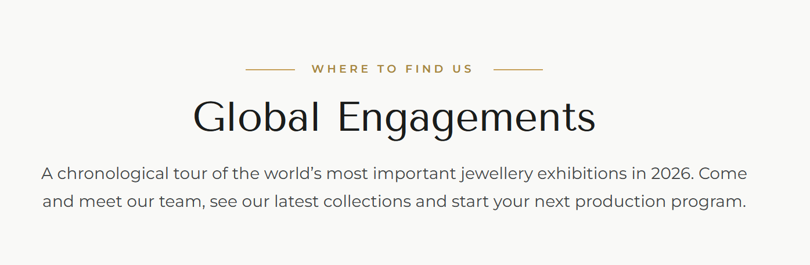
- Replace Global Engagements with text: Our 2026 Show Calendar
- Replace Text below it with: We exhibit at seven shows a year, spread across three continents with the same teams you'd meet in our factory in Bangkok. Here's where to find us in 2026.

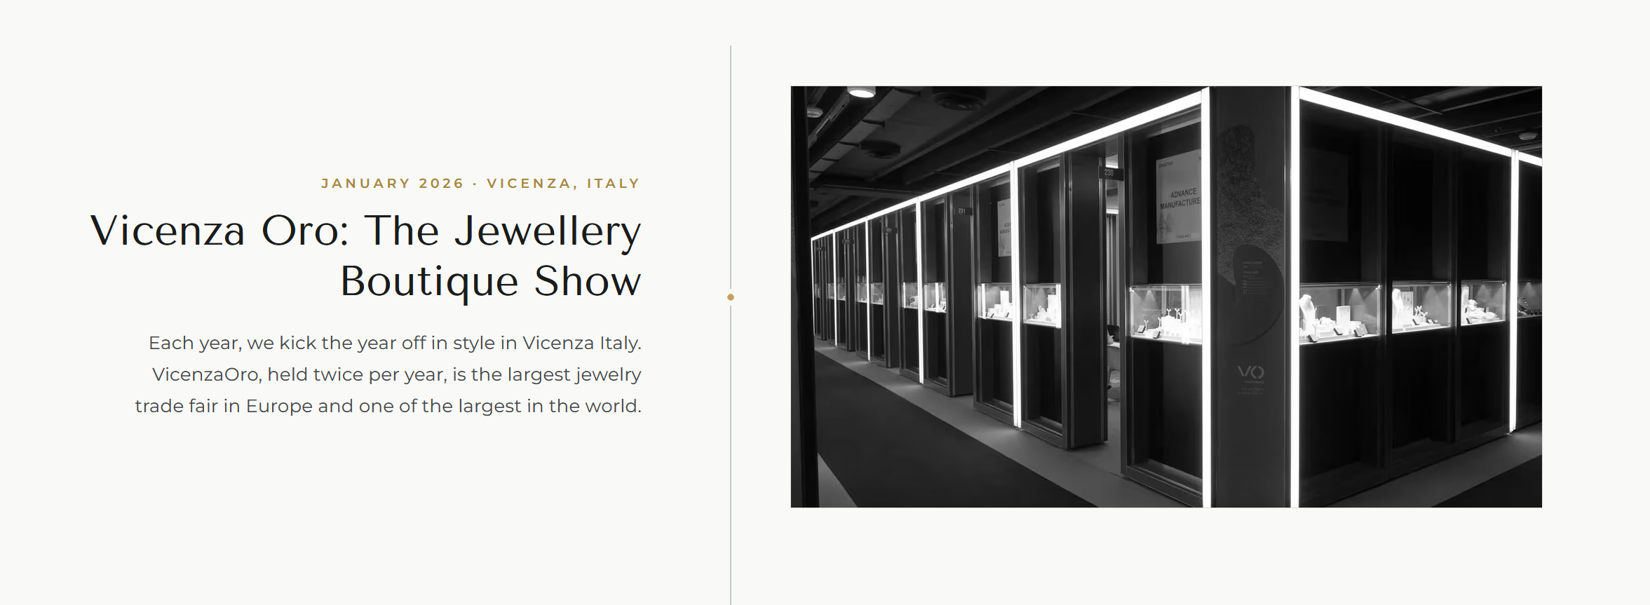
- Update Text: January 16th- 20th 2026 · Vicenza, Italy
- Remove The Jewellery Boutique Show and replace with: Vicenzaoro: Hall 3.1, Booth 248
- Replace the full text starting with Each Year… to: Vicenza is where our new collections are seen for the first time. Everything we've been developing since our last show of the year goes on the stand in January. If you want the earliest look at what we'll be making, this is the show.

- Add Bangkok Jewelry Fair between January Vicenza and March Hong Kong
Text (small brown one): 22nd – 26th February 2026 · Bangkok, Thailand
Bangkok Gems & Jewelry Fair: Booth Q-14,16 / R-13,15, G Floor QSNCC
Our home show. New collections and long-running favorites are both available at the booth and clients who'd like to see the factory are welcome. Just let us know ahead of the fair so we can set it up properly.

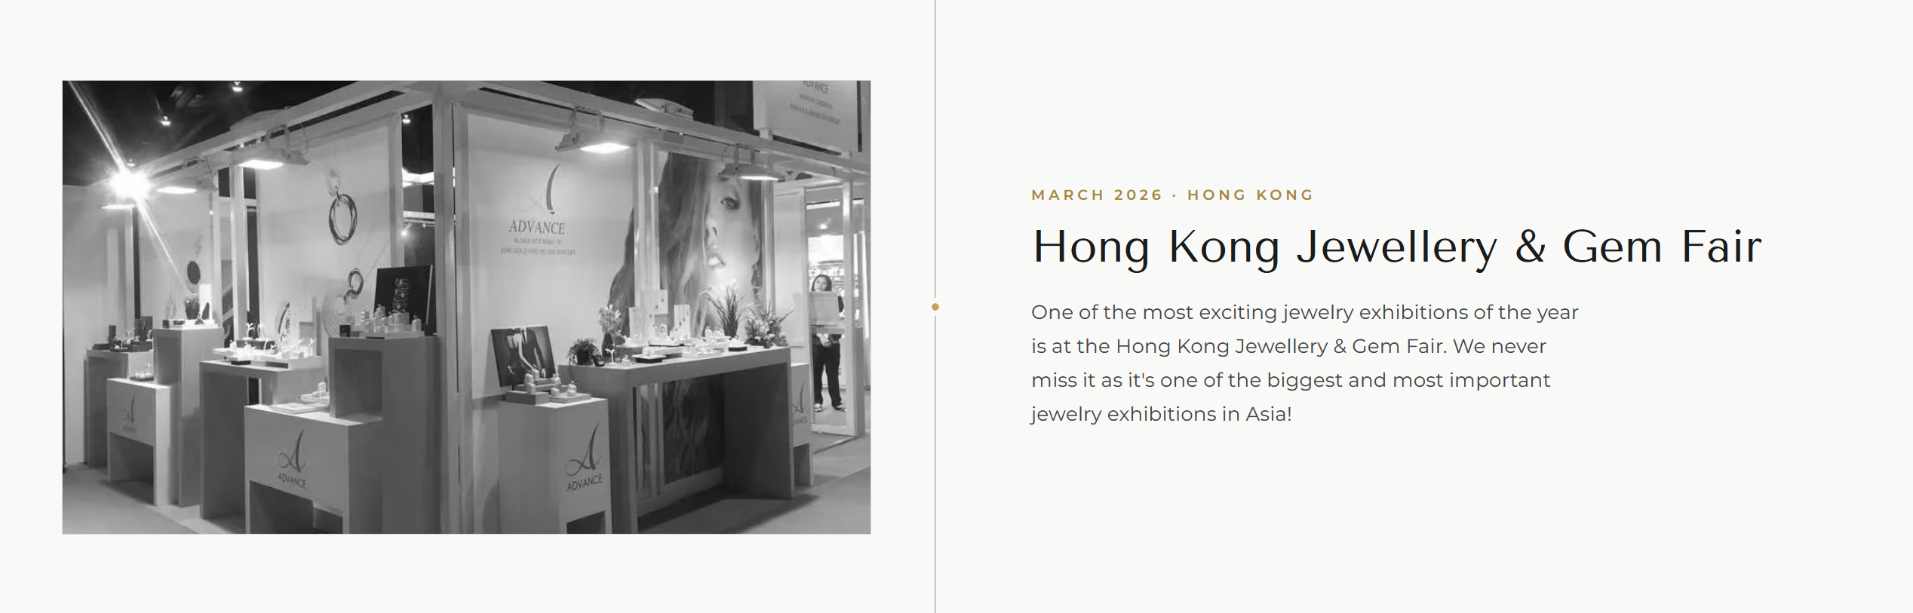
- Update Text: 4th-8th March 2026 · Hong Kong
- Update Text: Hong Kong International Jewellery Show: Booth 5E-E02
- Update Text: March is when many of our clients begin sourcing for fall and the holiday season, which makes this a productive show for first conversations about the year ahead.
- Add Section for JCK:
- 29th May–1st June 2026 · Las Vegas, USA
- JCK Las Vegas: Booth 45008, Thai Pavillion
- Text: Our first year back at JCK after a long hiatus but back due to popular demand. Late May is when a lot of US buying for the following year takes shape, so it's a useful moment for a first conversation including the practical parts about tariffs and landed costs.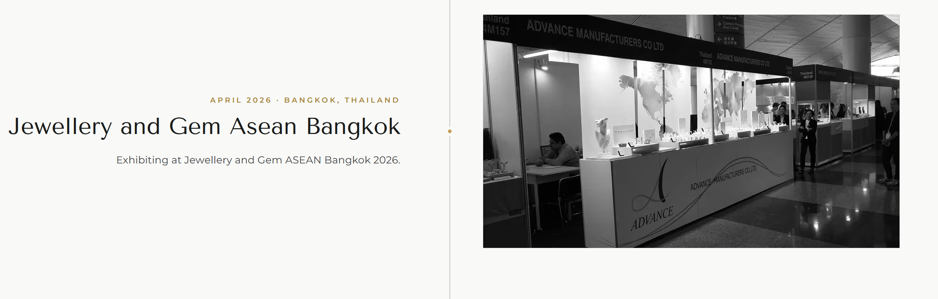
- Change Jewellery and Gem Asean Bangkok to: 4th- 8th September 2026 · Vicenza, Italy
- Vicenzaoro: Hall 2.1, Booth 234-236
- Add Text: Our second Vicenza show of the year looks in both directions: new designs for the season ahead, alongside the pieces that have sold best over the past twelve months.
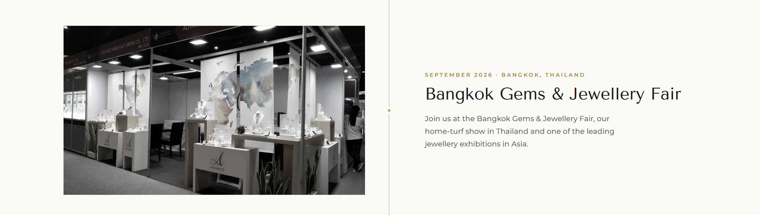

- Update Text: 8th –12th September 2026 · Bangkok, Thailand
- Update Text: Bangkok Gems & Jewelry Fair: Booth Q-14,16 / R-13,15, G Floor QSNCC
- Update text: Our second home show of the year, and the last chance to place work before the year-end run. The same invitation stands: tell us in advance and we'll arrange a factory visit while you're in Bangkok.
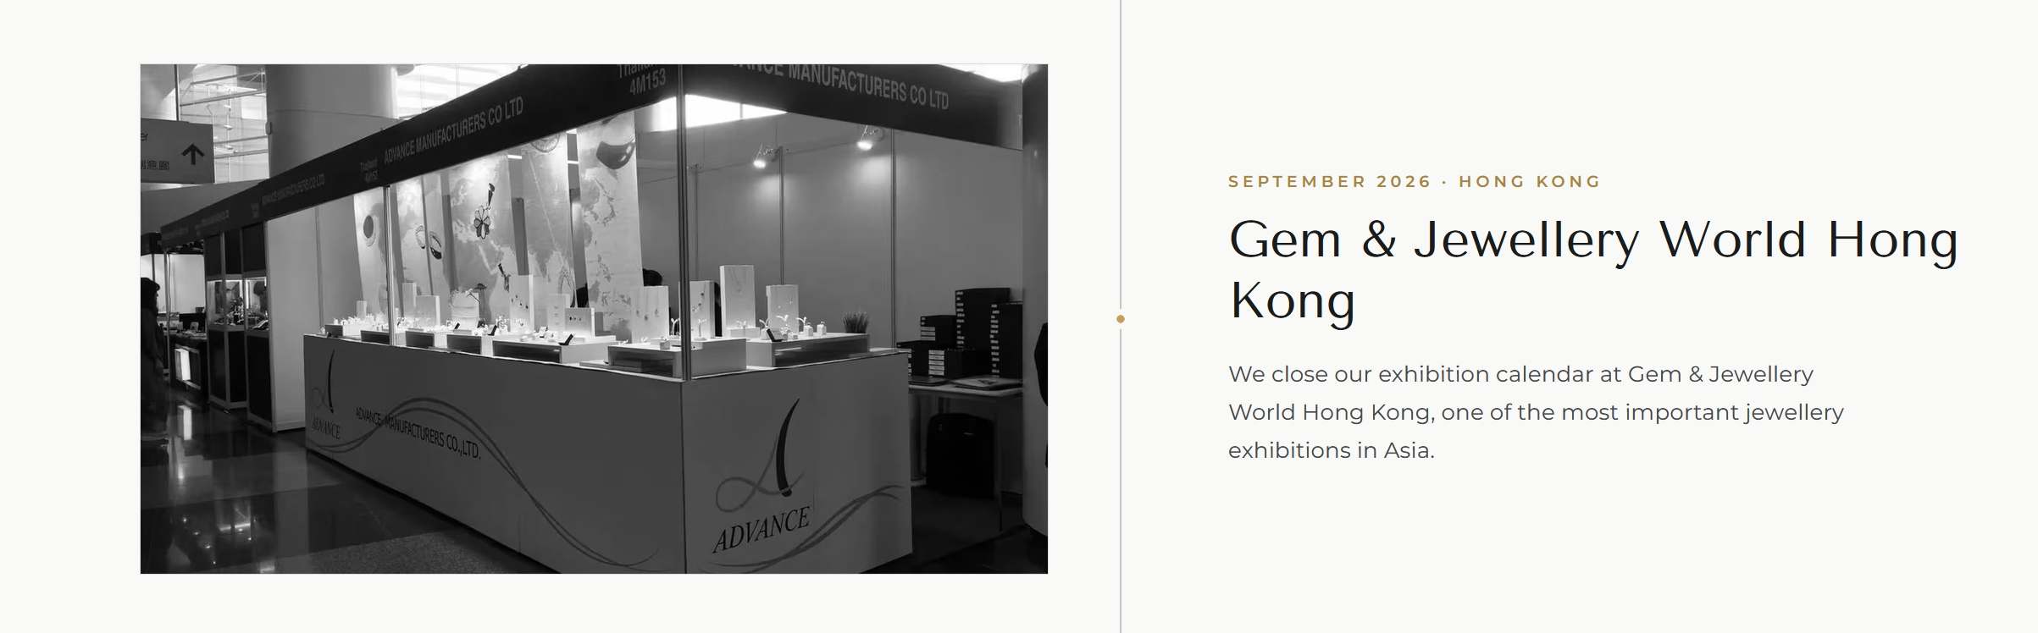
- Update Text: 16th – 20th September 2026 · Hong Kong
- Jewellery & Gem WORLD Hong Kong: Booth 5F101
- We close the exhibition year in Hong Kong with everything the past twelve months have produced on one stand; a good fit if you're finalizing programs for the season ahead.

