Home Page Notes
- Make the font of the headers bigger. Only slightly is fine, right now its too small

- Add Advance Logo top left, next to ADVANCE MANFACTURERS


Location of Logo File: https://www.dropbox.com/scl/fo/6t4hso4uto5bu2a0ee4f3/AH6eFdX2VNaMra7UQ5x25Wc?rlkey=i3uw882ta5kq3tz0hb9qyoyza&st=02w42o1j&dl=0
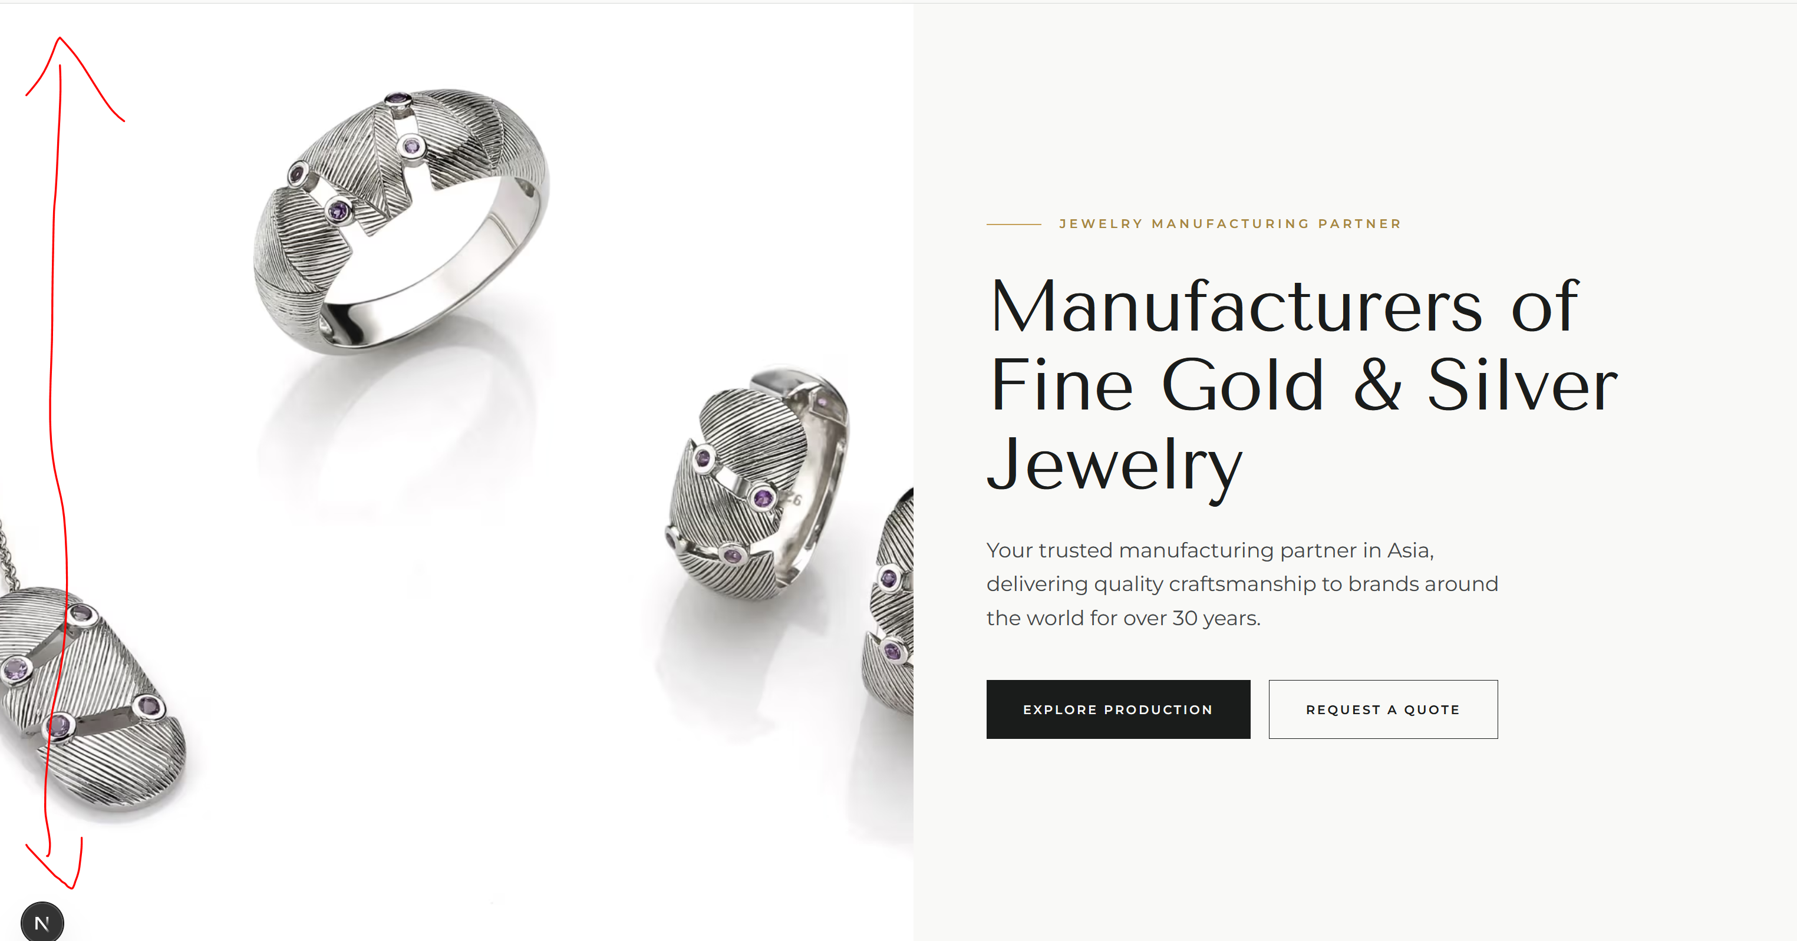

- The height of this is too big- can we reduce so it matches the height of the production landing/hero image

- Change text to : Your trusted manufacturing partner in Asia, delivering quality craftsmanship to brands around the world for over 37 years.
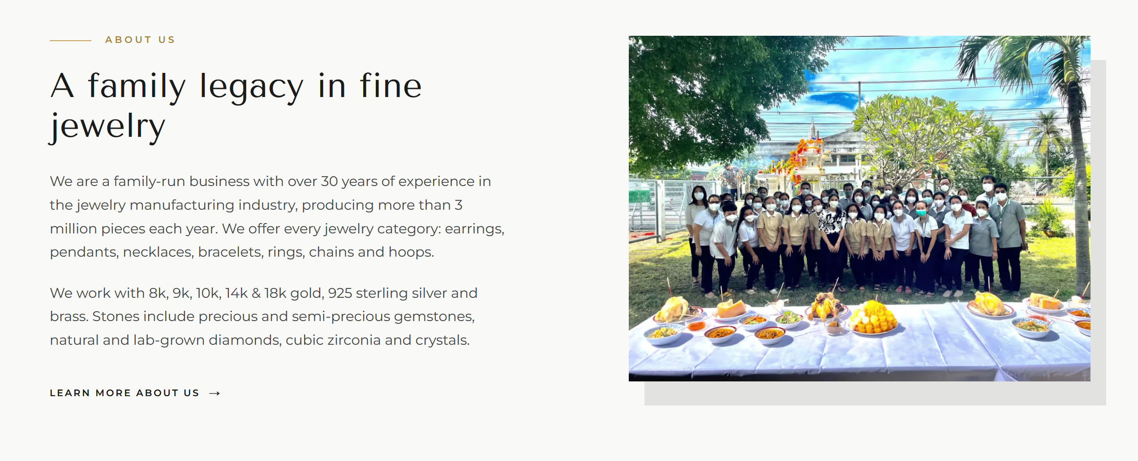
- Remove A family legacy…
- Update Text: We're an RJC-certified factory in Bangkok, family-run since 1989, producing over 3.5 million pieces a year for brands, wholesalers and retail chains in 42 countries. Our 5,000 sqm factory houses every stage of production and around 500 craftspeople, many with us for three decades or more. Skills here are taught, not hired in. Senior craftspeople train the next generation at the bench, and what they know is documented rather than remembered — which is how techniques we were using in 1989 are still being taught, and still improving, today.
- 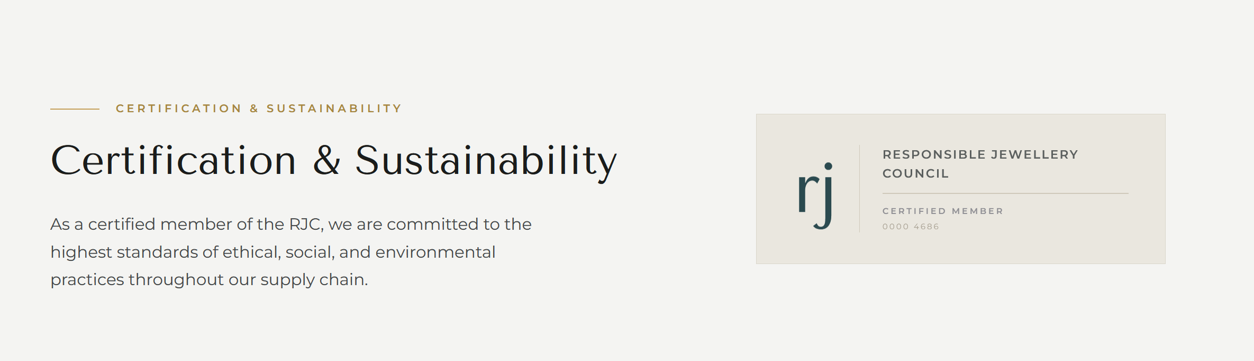
- Update Photo of RJC certificate with this one: (Its PDF do you need jpeg one?)
https://www.dropbox.com/scl/fi/t7xffeftfl5z9rkddhztf/0000-7445-Template-D-DOUBLE-Logo-COP-and-LGMS-US-Ivory-1.pdf?rlkey=wc6jkodoerl3nb4bzv2nn2xg4&st=qt6t4kcb&dl=0

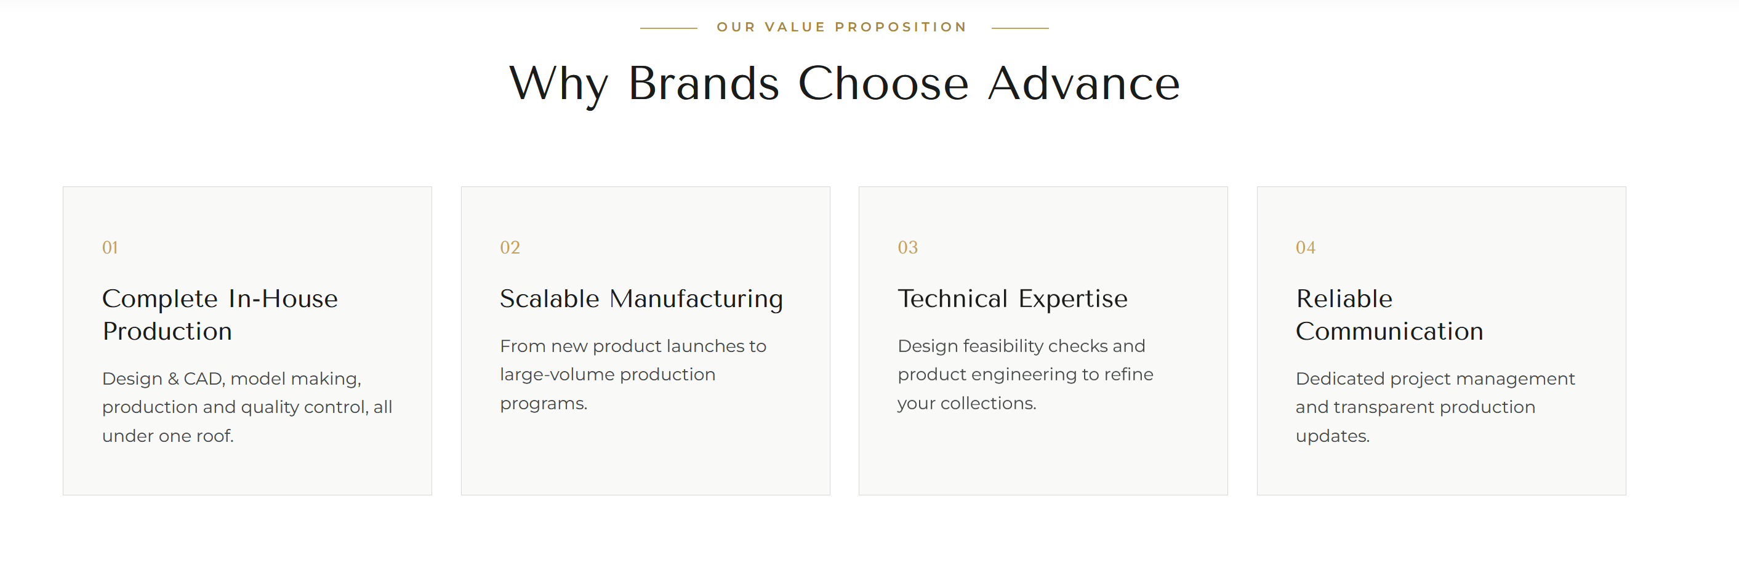
- Change format of all text in boxes to center alignment 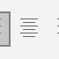
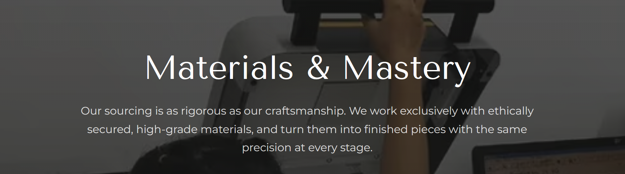
- Change Materials & Mastery to Materials & Standards
- Update Text: Our sourcing is as rigorous as our craftsmanship. Gold and diamonds come through supply chains documented under OECD due diligence guidance and the Kimberley Process and we offer recycled metals and certified conflict-free gemstones as options across our collections.
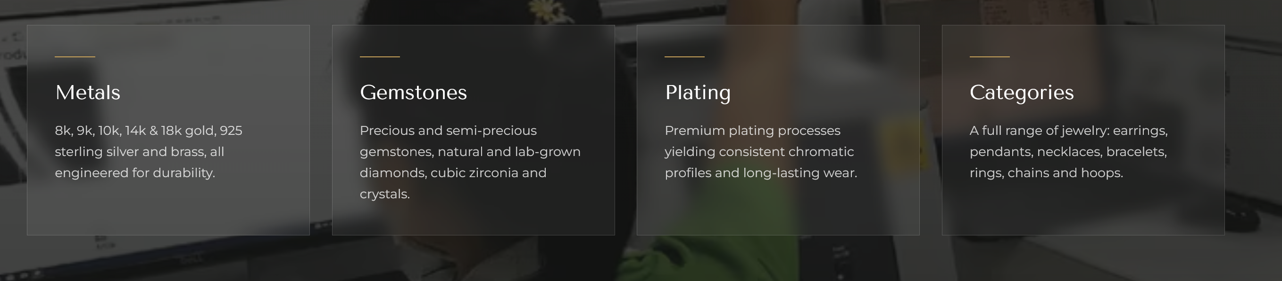
- Change format of all text in boxes to center alignment

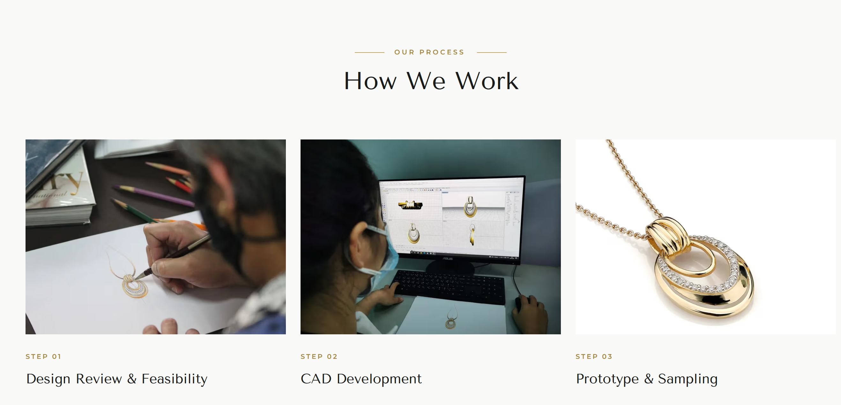
- How we Work: Give me size requirement of photos, I will prepare all new
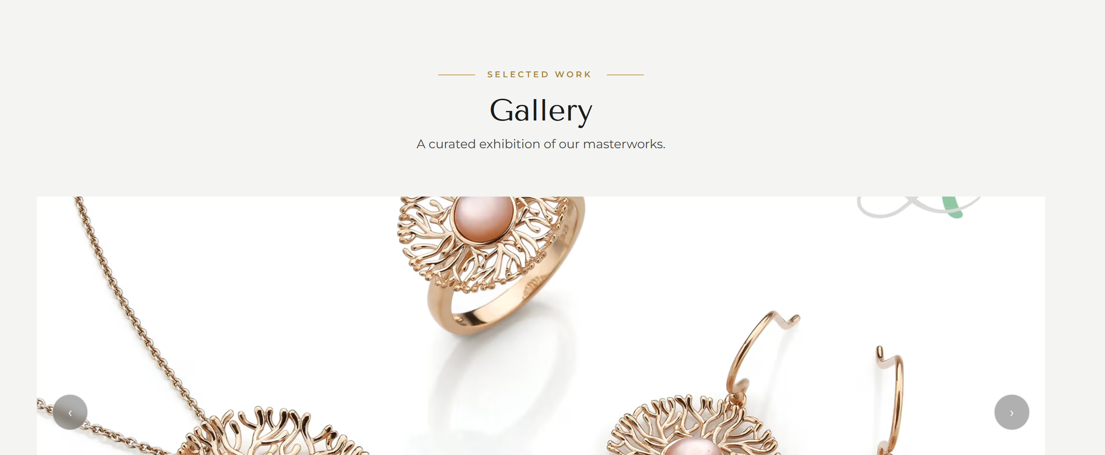
- Give me photo requirement of Gallery, I will update new photos all. Also update to 12 photos in this slide show

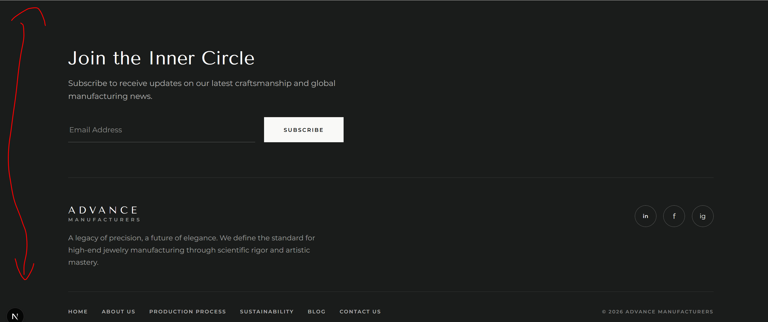
- Make this height slightly smaller, tighter, looks too big-
- Change Join the Inner Circle to Join Our newsletter list
- Change Text here: (Below Advance Manufacturers) : RJC-certified fine jewelry manufacturer in Bangkok. Family-run since 1989, producing gold, silver and brass jewelry for brands, wholesalers and retail chains worldwide.
- Change the icons for Instagram, facebook, linkedin. I will send you the icons I want later today. 18/08/2026

